**VISUALIZATION TOOL FOR ELECTRIC VEHICLE CHARGE AND RANGE ANALYSIS**

**INTRODUCTION**

**OVERVIEW:**

Electric bicycles have many advantages such as low cost,

energy saving, and simple to use. By the end of 2015, China

has 210 million electric bicycles [1]. Single electric bicycle

charging load is only around 100~200W. However, when the

total number of electric bicycles reach millions, its overall load

cannot be ignored. With great randomness and uncertainty, millions of electric bicycles charging load will cause a certain degree of impact on power distribution network.

The disordered charging behavior of electric bicycles may be superimposed with domestic electricity demand, leading to the problem of "peak-plus-peak", which affects the safety and reliability of power transformers, especially those with smaller capacity. Moreover, due to the combustion characteristics of lead-acid batteries, large-scalÍe electric bicycle charging will cause fire hazards. These two issues are urgent need to know by local electricity company

**PURPOSE:**

This paper aims to study the influence of large scale electric

bicycle charging in space and time. For this purpose, we

conducted online survey which could collect geographic

information about where users charge their bicycles. We

simulate real-time demand curve, and then estimated the

influence of electric bicycles charging in space domain using a

model based on heat map.

The remainder of the paper is organized as follows. Section

Ⅱintroduces methodology including dataset. Section Ⅲ

presents results with discussion, In order to better understand

the electric bicycle charging behavior, we will refer to the

existing electric vehicle research for comparison in this section.

PROBLEM DEFINITION AND DESIGN THINKING

EMPATHY MAPPING

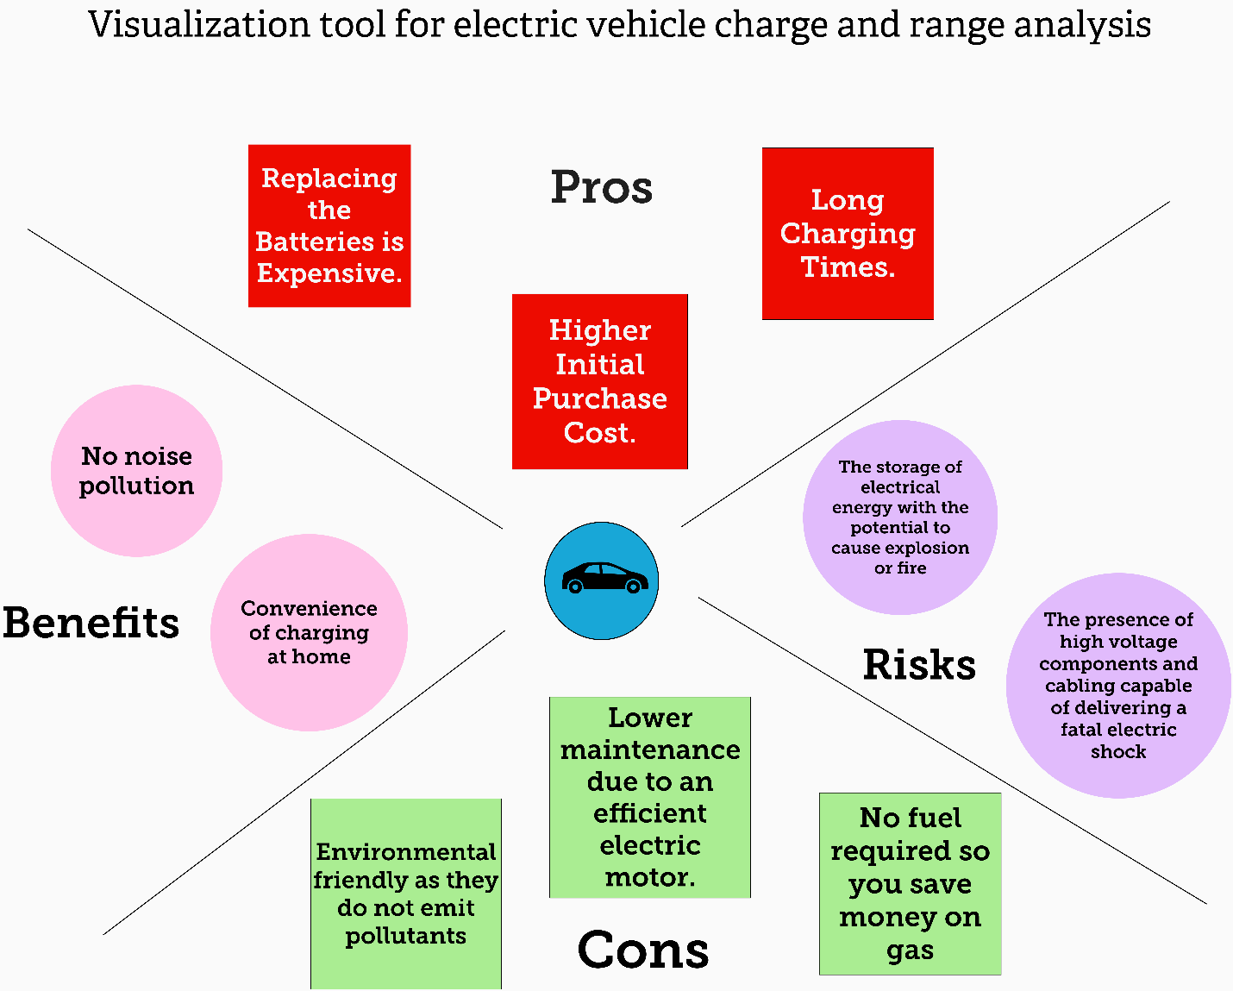

BRAINSTORMING AND IDEATION

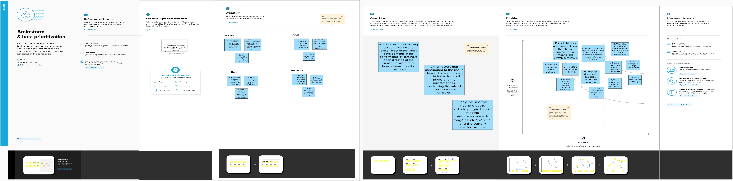

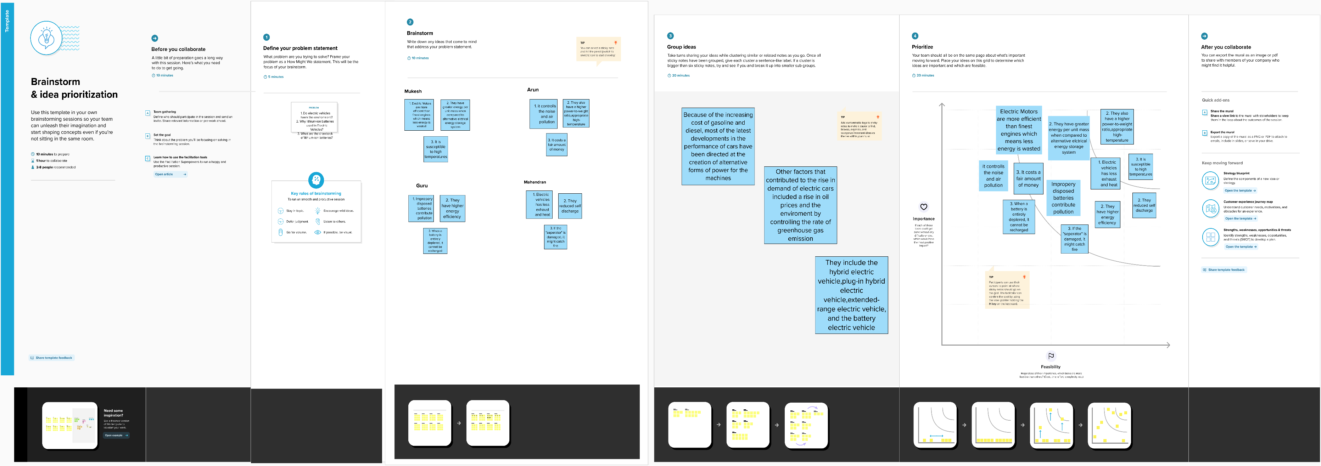

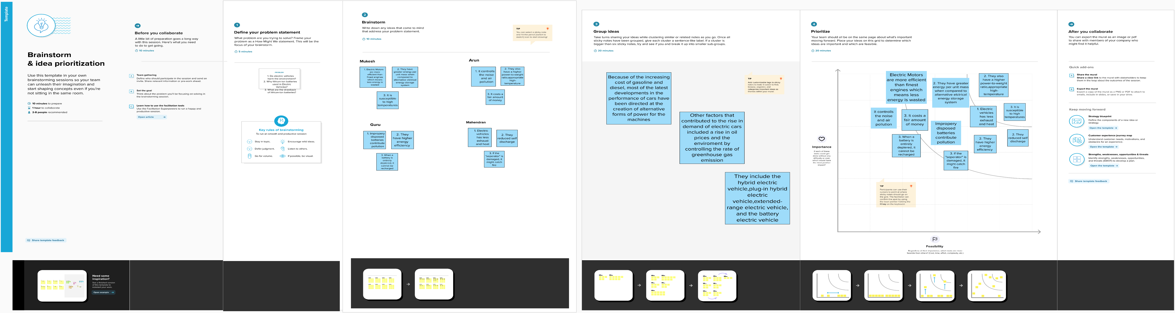

RESULT

ACTIVITY 1.1

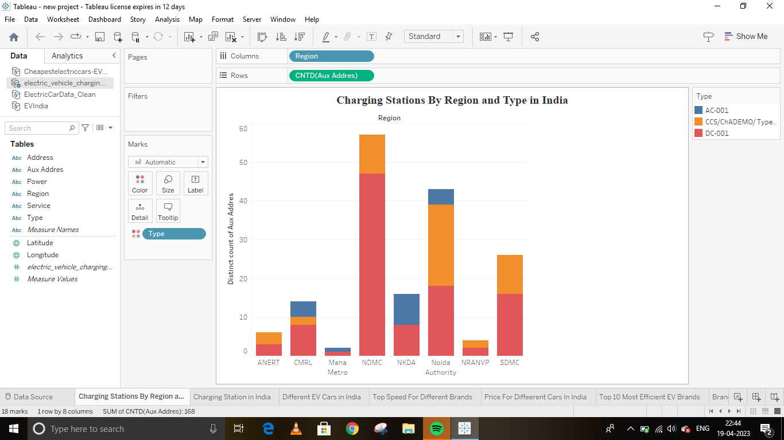

ACTIVITY 1.2



ACTIVITY 1.3



ACTIVITY 1.4



ACTIVITY 1.5



ACTIVITY 1.6



ACTIVITY 1.7



ACTIVITY 1.8



ACTIVITY 1.9



ACTIVITY 1.10



ACTIVITY 1.11



ADVANTAGES:

**Eco-friendly:**Because electric vehicles do not utilize fuel for combustion, there are no emissions or gas exhaust. Vehicles that run on fossil fuels contribute significantly to hazardous gas accumulation in the environment, thus driving an electric car can help contribute to a cleaner environment.

**Renewable energy source:** Electric vehicles run on renewable power, whereas conventional automobiles function on the combustion of fossil fuels, which reduces the world’s fossil-fuel stocks.

**Less noise and smoother motion:** Driving an electric car is significantly smoother. Because they lack fast-moving elements, they are quieter and produce less noise.

**Cost-effective:** Electricity is far less expensive than fuels such as gasoline and diesel, which are subject to regular price increases. When solar electricity is utilized at home, battery recharging is cost-effective.

**Low maintenance:** Because electric cars have fewer moving components, wear and tear is reduced when compared to traditional auto parts. Repairs are also simpler and less expensive than combustion engines.

**Government support:** Governments throughout the world have granted tax breaks to encourage people to drive electric vehicles as part of a green program.

DISADVANTAGES:

**High initial cost:**Electric vehicles continue to be quite expensive, and many buyers believe they are not as inexpensive as traditional automobiles.

**Charging station limitations:** People who need to travel long distances are concerned about finding adequate charging stations in the middle of their journey, which are not always accessible.

**Recharging takes time:** Unlike conventional automobiles, which require only a few minutes to replenish their gas tanks, charging an electric vehicle takes many hours.

**Limited options:**Currently, there aren’t many electric car models to pick from in terms of appearance, style, or customized variations.

**Less driving range:**When compared to conventional automobiles, electric vehicles have a shorter driving range. Electric cars can be convenient for short-distance travel but are inconvenient for long-distance travel.

APPLICATION:

* **Reduced Pollution**  
  The transportation sector is now the largest source of carbon dioxide emissions in the U.S. The continued integration of EVs will help reduce this impact because they produce 54 percent less carbon dioxide emissions per mile than a conventional vehicle.
* **Cost Savings**  
  EV batteries convert 59 to 62 percent of energy into vehicle movement while gas powered vehicles use 17 and 21 percent. EV drivers spend about $1.2 per gallon to charge, less than half the price of gasoline. The average operating cost of an EV is $485 annually compared to $1,117 for a conventional vehicle.
* **Economic Growth**  
  According to the U.S. Department of Energy, in 2017, the U.S. imported 19 percent of the petroleum it used. Using Electric Vehicles can reduce our energy dependency abroad and support the U.S. economy through the generation of new jobs, particularly in skilled electrical trades.

CONCLUSION:

* + Charging Stations by Region and Type in India
  + EV Charging station map of India
  + Different EV cars in India
  + Top speed for different Brands
  + Price for different cars in India
  + Top 10 most efficient EV Brands
  + Brands according to Bodystyle
  + Brands filtered by powertrain type
  + No of models by each brand
  + Different Brands of EV Cars Globally
  + Different Brands of EV Cars in India

FUTURE SCOPE:

Electric vehicles have enormous future potential. The charging station is the obvious starting point for these vehicles. However, this is only the first step in a potentially long journey that will include charging banks and other industrial areas, as well as homes and cities. Electric vehicle technology has existed in labs such as NASA since the 1970s. In a few years, current technology will undoubtedly be far more advanced. EVs are even expected to power themselves by harvesting energy from their surroundings. Such vehicles will require little maintenance and may even be powered by renewable energy sources such as wind. It will also be interesting to see the impact of EU and US regulations that will go into effect. These regulations are intended to reduce the use of gasoline-powered vehicles. As the popularity of electric vehicles grows, so will the need to reduce their use. It is obvious that new zero-emission technologies will be required.

One of the most important aspects is the power source, and the global market segmentation is thoroughly examined. Electric vehicles today use a variety of power sources, including wind power, solar power, and hydroelectric power. The majority of these technologies have emerged in Africa. Morocco, South Africa, Tanzania, Namibia, Zimbabwe, and Brazil are among the countries that have developed these technologies. It should be noted that all of these countries have very low fuel costs, which means that installing a charging system on cars is very affordable. All over the world, batteries have been the primary concern. Lithium-ion batteries are replacing traditional alkaline batteries as technology advances. This has presented a significant challenge to the manufacturers. The market research report provides information on the major key players in this industry as well as the various strategies they are employing to overcome the challenges.

APPENDIX:

SOURCE CODE

For further information click the link below

Dashboard

# <https://public.tableau.com/views/dashboard1_16818825191210/Dashboard1?:language=en-US&:display_count=n&:origin=viz_share_link>

Story <https://public.tableau.com/views/story_16818832558180/storyofelectriccarsinindia?:language=en-US&:display_count=n&:origin=viz_share_link>

<file:///C:/Users/ELCOT/Downloads/Gp/index.html>